20200325

20200054

Ezz Eldin Ahmed Saber

Ahmed Hany Ibrahim Ahmed

**Abstract**

In the recent times and with the revolutionary evolution of GPUs and computational resources in general. Deep learning models have been used more often to make life easier and help the convenience of different applications in many fields. One of which is food quality supervision. Hereby we introduce a high accuracy CNN (convolutional neural network) architecture called VGG16 which detects certain features based on which the classification is done. Those features are filtered and refined using the GA (genetic algorithm) and then an SVM (support vector machine) classifying model to detect and classify whether a fruit is fresh or rotten judging the feature nominated by the GA.

# INTRODUCTION

In a world struggling with the challenges of food security and sustaіnabіlіty, ensuring the freshness of our produce turns out to be a critical aspect of maіntaіnіng both nutritional value and consumer satisfaction. Amongst various food items, fruits stand out as perishable commodities that demand vigilant monitoring to guarantee their quality. The advent of deep learning techniques, particularly Convolutional Neural Networks (CNNs), has opened up new possіbіlіtіes for enhancing the efficiency and accuracy of fruit freshness detection.

# RELATED WORK

This section briefly discusses recent methods that aim to classify various fruits using machine learning and image processing-based methods.

In [1], a pre-trained CNN model, specifically ResNet50, is employed. This model extracts high-level features from the fruit images and these extracted features serve as input to an SVM classifier to predict the freshness of the fruits. In [2], a pre-trained CNN model is employed to extract relevant features from the fruit images. And In this work, transfer learning is explored in the context of fruit classification using CNNs. The proposed model fine-tunes a pre-trained CNN (specifically, VGG-16) to classify fresh and rotten fruits. The proposed model achieves an impressive accuracy of 97.82% on a dataset obtained from Kaggle.

In [3], the authors introduce a novel deep learning-based architecture called Fruit-CNN. It is designed to identify the type of fruit and assess its quality using real-world images with multiple visual variations. Remarkably, the proposed

Fruit-CNN achieves a test accuracy of 99.6% in fruit quality assessment. In [4], the authors propose an ensemble model that combines the bottleneck features of two multi-task deep CNNs with different architectures: ResNet-50 and ResNet-101. The proposed ensemble model achieves 98.50% accuracy.

In [5], the authors employ an attention-based variant of MobileNetV2, a lightweight CNN architecture and use data augmentation techniques such as flip, hue/saturation



Omar Mahmoud Abdulaziz

20200361

changes, and gray-scale are applied to enhance model robustness. The CNN model achieves an impressive accuracy of 95.23% in fruit classification. In [6], researchers extract diverse features from fruit images, including shape, size, color, and texture. For classification, various machine learning methods are applied (k-nearest neighbors (KNN), Support Vector Machine (SVM), Neural Networks). The paper compares different techniques proposed by researchers for fruit quality detection.

In [7], Transfer learning leverages pre-trained CNN models (such as ResNet50, AlexNet, and VGG-16) to improve performance on specific tasks. And Test accuracy score greater than 99% for fruit freshness classification. In [8], the freshness grading scheme relies on visual analysis of digital fruit images. Several deep learning methods are explored: AlexNet serves as the base network, ResNet, VGG, and GoogLeNet are also employed and YOLO (You Only Look Once) is used for region-of-interest (ROI) extraction from images. In [9], it utilizes a sequential two-dimensional convolutional neural network (CNN) model and fine-tune the CNN model using transfer learning techniques. The proposed model achieves accuracy of 96% in recognizing both the type and freshness of fruits after training on 6000 real-time fruit images.

In [10], the proposed approach utilizes an improved version of the YOLOv4 model. The YOLOv4 model first identifies the object type (fruit or vegetable) in an image then classifies the object into one of two categories: fresh or rotten. The key steps include dataset creation, data augmentation, and model optimization. In [11], the authors analyze the changing process of banana freshness using transfer learning. They establish a relationship between freshness and storage dates. The key steps include: Automatically extracting features from banana images using the GoogLeNet model. And Classifying banana freshness based on extracted features using a classifier module. The proposed model detect banana freshness with an impressive accuracy of 98.92%, surpassing human detection levels.

In [12], Using the K-means clustering method, the system identifies the infected parts of the apple. And Color-, texture-, and shape-based features are computed over the segmented apple image and combined to form a single descriptor. Then a multi-class support vector machine (SVM) is used to classify apples as healthy or infected. In [13], the proposed system combines three powerful deep learning models: CNN for feature extraction from fruit images, RNN to capture temporal dependencies in sequences of features and LSTM for handling sequential data. These models work together to recognize and classify fruit images

# EXPERIMENTAL RESULT

## Dataset acquisition and pre-processing

The dataset, sourced from Kaggle, comprises 13,599 images featuring three types of fruits—apples, bananas, and oranges—each categorized into two classes: fresh and rotten. The dataset is divided into training, validation, and test sets, with 7,630, 3,271, and 2,689 images, respectively. The distribution of samples for each class is visualized in Figure 1. To standardize the input, all images are resized to 224x224x3 pixels and converted into NumPy arrays. This preprocessing step ensures uniformity and facilitates subsequent analysis or model training on the comprehensive dataset.

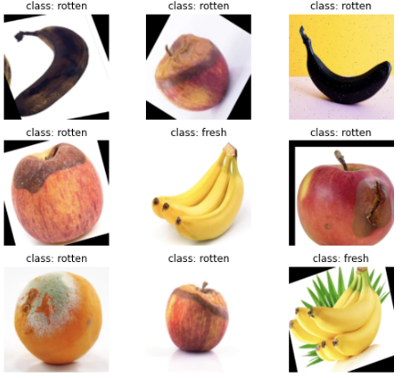

**Figure 1.** Sample images of dataset

## Evaluation metrics

For evaluating the model we used precision, recall, f1-score and confusion matrix. A confusion matrix is a table that describes the performance of a classification algorithm. It shows the true positives (TP), true negatives (TN), false positives (FP), and false negatives (FN). It's a helpful tool to visualize the performance of a model and calculate other metrics like precision and recall. As for the precision, recall, f1-score, precision is the ratio of correctly predicted positive observations to the total predicted positives. It's a measure of how many of the predicted positive instances are actually relevant, recall is the ratio of correctly predicted positive observations to the all observations in the actual class. It's a measure of how many of the actual positive instances were correctly predicted, lastly the f1-score is the harmonic mean of precision and recall. It provides a balance between precision and recall.

For applying the confusion matrix we used confusion matrix function in the sklearn.metrics library and apply it on the prediction of the X_test (predicted labels of test set) and the y_test (true labels of test set), then used seaborn heatmap to visualized the confusion matrix.

**Figure 2.** Confusion matrix

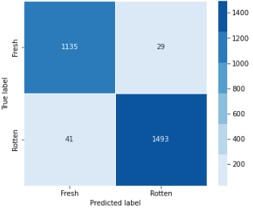

Then for the precision, recall and f1 score, we used classification_report which is also from the sklearn.metrics library and also apply it on the prediction of the X_test (predicted labels of test set) and the y_test (true labels of test set).

**Figure 3.** Precision, recall and f1-score values

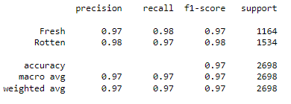

# PROPOSED MODEL

In our work, initial processing involved feature extraction through transfer learning utilizing VGG16, a pretrianed model on the ImageNet dataset, with an input shape set to (224x224x3) followed by GlobalAveragePooling2D layer to generate compact fixed-size representation of the input future maps which helps in reducing the total number of parameters in the model, preventing overfitting, and providing a form of translation invariance. Following feature extraction, we employed a Genetic Algorithm as an optimization technique for feature selection. Subsequently, a Support Vector Machine (SVM) classifier was employed to classify the dataset based on the selected features. This two-step approach, combining transfer learning for feature extraction and genetic algorithms for feature optimization, was then complemented by the SVM classifier to effectively categorize the data.

For applying Genetic Algorithm we used DEAP (Distributed Evolutionary Algorithms in Python) which is a Python framework designed for the development and execution of evolutionary algorithms. It provides a set of tools, algorithms, and components to facilitate the implementation of genetic and evolutionary algorithms for various optimization and modeling tasks. Then we developed a fitness function to evaluate the performance of an individual by training an SVM classifier on the selected features and computing the accuracy on a validation set.

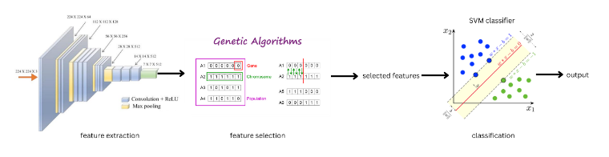**Figure 4.** Model architecture

# CONCLUSION

In conclusion, the advancement of GPUs and computational resources has paved the way for the widespread utilization of deep learning models in various applications, including food quality supervision. The VGG16 CNN architecture, with its high accuracy, serves as a robust tool for detecting key features in fresh and rotten fruits. The integration of a Genetic Algorithm (GA) enhances the precision by filtering and refining these features. Finally, a Support Vector Machine (SVM) classifying model effectively categorizes fruits based on the optimized features, culminating in a powerful system for discerning and classifying the quality of fruits with remarkable accuracy.

# REFERENCES

1. "Identify the Freshness of the Fruit by Using CNN and SVM" by Rashawn Yashadhana; Jason William Conrad; Nathan Raditya Hemanda; Henry Lucky; Irene Anindaputri Iswanto. [[Link](https://ieeexplore.ieee.org/document/10284607)]
2. “Fresh and Rotten Fruits Classification Using CNN and Transfer Learning” by Sai Sudha Sonali Palakodati, Venkata RamiReddy Chirra, Yakobu Dasari, Suneetha Bulla. [[Link](https://www.iieta.org/journals/ria/paper/10.18280/ria.340512)]
3. “Fruit-CNN: An Efficient Deep learning-based Fruit Classification and Quality Assessment for Precision Agriculture” by Arnav Kumar; Rakesh Chandra Joshi; Malay Kishore Dutta; Martin Jonak; Radim Burget. [[Link](https://ieeexplore.ieee.org/document/9631643/)]
4. “Ensemble of multi-task deep convolutional neural networks using transfer learning for fruit freshness classification” by Jaeyong Kang & Jeonghwan Gwak. [[Link](https://link.springer.com/article/10.1007/s11042-021-11282-4)]
5. “Improved Classification Approach for Fruits and Vegetables Freshness Based on Deep Learning” by Mukhriddin Mukhiddinov, Azamjon Muminov and Jinsoo Cho. [[Link](https://www.mdpi.com/1424-8220/22/21/8192)]
6. “Recent Advancements in Fruit Detection and Classification Using Deep Learning Techniques” by Chiagoziem C.Ukwuoma, Qin Zhiguang, Md Belal Bin Heyat, Liaqat Ali, Zahra Almaspoor and Happy N. Monday. [[Link](https://www.hindawi.com/journals/mpe/2022/9210947/)]
7. "Determining the freshness of fruits in the food industry by image classification using transfer learning" by Aafreen Kazi & Siba Prasada Panda. [[Link](https://link.springer.com/article/10.1007/s11042-022-12150-5)]
8. "Grading Methods for Fruit Freshness Based on Deep Learning" by Yuhang Fu, Minh Nguyen & Wei Qi Yan. [[Link](https://link.springer.com/article/10.1007/s42979-022-01152-7)]
9. . "A Design of Deep Learning Experimentation for Fruit Freshness Detection" by Febrian Valentino, Tjeng Wawan Cenggoro and Bens Pardamean. [[Link](https://iopscience.iop.org/article/10.1088/1755-1315/794/1/012110)]
10. "Improved Classification Approach for Fruits and Vegetables Freshness Based on Deep Learning" by Mukhriddin Mukhiddinov, A. Muminov, Jinsoo Cho. [[Link](https://www.semanticscholar.org/paper/Improved-Classification-Approach-for-Fruits-and-on-Mukhiddinov-Muminov/e772cc5a73b8793eb9eefa6792cc7d337dea5230)]
11. "Monitoring the Change Process of Banana Freshness by GoogLeNet" by Jiangong Ni; Jiyue Gao; Limiao Deng; Zhongzhi Han. [[Link](https://ieeexplore.ieee.org/document/9296756)]
12. "Apple disease classification using color, texture and shape features from images" by Shiv Ram Dubey & Anand Singh Jalal. [[Link](https://link.springer.com/article/10.1007/s11760-015-0821-1)]
13. "Multi-Model CNN-RNN-LSTM Based Fruit Recognition and Classification" by Harmandeep Singh Gill, Osamah Ibrahim Khalaf, Youseef Alotaibi, S. Alghamdi, Fawaz Alassery. [[Link](https://www.semanticscholar.org/paper/Multi-Model-CNN-RNN-LSTM-Based-Fruit-Recognition-Gill-Khalaf/065a37d3580e2a54c8894d0ea21a0ae7f9fdca07#cited-papers)]
14. "Automatic fruit and vegetable classification from images" by A. Rocha, D. C. Hauagge, Jacques Wainer, S. Goldenstein. [[Link](https://www.semanticscholar.org/paper/Automatic-fruit-and-vegetable-classification-from-Rocha-Hauagge/4ca84359e3536e39e3b179f3b9579ed20201e9db)]
15. "Automatic Fruits Freshness Classification Using CNN and Transfer Learning" by Umer Amin, Muhammad Imran Shahzad, Aamir Shahzad, Mohsin Shahzad,Uzair Khan and Zahid Mahmood. [[Link](https://www.mdpi.com/2076-3417/13/14/8087)]